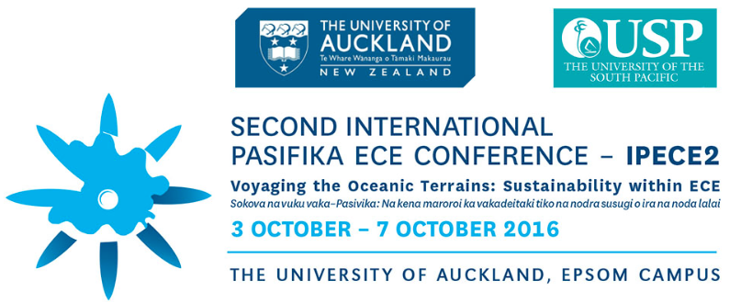

Time | Tuesday  4th October  Professional Development Workshop for Teachers | Wednesday Thursday Friday  5th October 6th October 7th October  The 2nd International Pasifika ECE Conference
8.00am | Workshop Registration | Conference Registration | Conference Registration | Conference Registration
8:30am to  9:40am  9.15am | 9:00am – opening of Tuatua mai / talanoa workshops  Keynote Speaker: Professor Margaret Sims  Children’s rights: a different planning approach | Powhiri  Tūtahi Tonu  Morning Tea will be  in the whare kai straight after powhiri  Music Auditorium  Opening Lotu/Pūre  Rev. James Matamua  Welcome by Professor Graeme Aitken  Associate Dean Tanya Wendt Samu  Keynote Speaker:  Professor Margaret Sims  9:45am  Is our voyage taking us to a Pasifika destination? | Keynote Speaker: Professor Airini  Remembering who we are: Pacific knowledge making for Pasifika ECE futures | Keynote Speaker:  Dr Diane Mara  Voyaging the Oceanic Terrains: Sustainability Within
10.00 10:20 | Morning Tea |  | Morning Tea  10:15 – 10:30 | Morning Tea  10:15 – 10:30
10.30am | Workshop 1  Curriculum Development: Manutai Leaupepe | 10:40am  Session 1  Calmar Ulberg & Vanessa Moodley  Not just one way to be a leader. | 10:40am  Session 7  Ali Glasgow  The Pacific language nest: Upholding and strengthening Pacific pedagogical knowledge and practice in early childhood education. | 10:40am  Session 13  Peta Ravlich  A Cook Island methodology for research - The tivaevae model.
11.10am | Workshop 2:  Pedagogical knowledge and practice.  Kelisi Whippy | 11:10am  Session 2  Tania Akai, Teokotai Taio, Eteta Teinangaro and Eitiare Vano  The importance of ECE in the Cook Islands: Teachers as researchers. | 11:10am  Session 8  Eneleata Tapusoa and Jan Taouma Teachers voyaging in plurilingual seas: Young children learning at the A’oga Fa’a Samoa  Please note this is a double session | 11:10am  Session 14  Robyn Trinick and Meripa Toso  Ta pepese faatasi: Pese as a vehicle of sustaining language and culture for early childhood education environments.
 |  | 11:40am  Session 3  Pauline Luafutu-Simpson  Testing the efficacy of a Samoan values frame within education spaces from ECE to Tertiary education. | 11:40am  Session 9  Eneleata Tapusoa and Jan Taouma Teachers voyaging in plurilingual seas: Young children learning at the A’oga Fa’a Samoa. | 11:40am  Session 15  Lilien Skudder  The thing that makes me different is the thing that makes me.  Kelesi Whippy  Na vakatatalo; play as is, not as the other
12:00 12:40 | Lunch | Lunch  12:10pm – 1:05pm  Special Interest Groups  Inclusive Education  [Manutai] | Lunch  12:10pm – 1:05pm  Special Interest Groups  OMEP Pacific Island Nations Committee | Lunch  12:10pm – 1:05pm  Special Interest Groups  Ulimasao  [Patisepa & Meripa]
12:40pm  1.45pm | Critical conversations: Policy and practice.  Kelisi Whippy  Workshop 3  Research: Vaovasamanaea Meripa Toso | 1:10pm  Session 4  Easter Molu  How effectively can formative assessment in the form of learning stories encourage Tuvaluan families to be involved in the assessment of their child's learning in early childhood settings? | 1:10pm  Session 10  Seiuli Luama Sauni & Sadhana Kumari  Teacher-student relationships the key to successful learning for international students | 1:10pm  Session 16  Meripa Toso  O le faatauaina o le Va I totonu o Aoga Amata: The Va within the context of Early Childhood Education.
2.25pm | Workshop 4  Leadership: Jacoba Matapo | 1:40pm  Session 5  Anoop Kumar  Culturally Responsive Pedagogy in early childhood education: The concept of Talanoa. | 1:40pm  Session 11  Pauline Harris, Ufemia Camaitoga and Mere Krishna, with Anne Glover, Elspeth McInnes, Jenni Carter, Alexandra Diamond, Cynthia Brock and Bec Neill.  Developing sustainable community approaches to fostering children’s literacy in their home languages and English in Fiji. | 1:40pm  Session 17  Jacoba Matapo  Traversing Pasifika leadership in early childhood education: shifting landscapes and tides of change.
3:10  3:25 | Afternoon Tea | 2:10pm  Session 6  Grace Unlimited Ltd  Driving Cultural Responsiveness through the Upper South Island –Future proofing Pasifika perspectives within mainstream ECE services. | 2:10pm  Session 12  John Rombo  Inclusive Leadership from the Pacific Perspective. | 2:10pm  Session 18  Manutai Leaupepe  Leadership and initial teacher education: What does this mean for Pasifika ECE?
3.30pm | Summary  Evaluation/  End of  programme | 2:40pm  Afternoon Tea | 2:40pm  Afternoon Tea | 2:40pm  Afternoon Tea
3.00pm |  | Evaluation  Professor Margaret Sims to summarise  End of Programme | Evaluation  Professor Airini to summarise  End of Programme | Evaluation  Dr Diane Mara to summarise  Hosting for 2019?  End of Programme  Closing Lotu/Pūre  Rev. James Matamua
4.00pm
7.00pm |  |  | OMEP [Pacific Island]  TBC – whare kai [marae] | Dinner at Valentines  Mt Eden  6.30pm till 9pm.  $26.95 pp  [Ref: Lilien Skudder]

For the first time we are running Special Interest Groups [SIGs] during the lunch breaks. Please feel free to organise these.
- OMEP – Pacific Island Nations Committee [Ulu & Nola]
- Ulimasao – [Patisepa & Meripa]
- Disability / Inclusive Education – [Manutai]

Awards for the following categories: Keynote speakers will be given the task of judging [committee members to assist, if required]

- Best poster
- Best group presentation [refers to Pasifika ECE teaching teams that are presenting]
- Best paper

